Name: Eliza Dahal

UN ID: 16418528

GitHub live URL: https://eliza07.github.io/csy1018-assign1/

|  |  |  |
| --- | --- | --- |
| Assignment 1-Web development | April 9  2017 | |
| This file includes the development process of my personal webpage. | | Assignment1-creating a personal webpage. |

Table of Contents

Starting my webpage 3

Designing part: 4

Rough sketch diagrams: 4

Home page sketch: 4

Bio page sketch: 5

Contact page sketch: 6

CV page sketch: 7

Wire frames: 8

Wireframe of my home page: 8

Wireframe of my biography page: 9

Wireframe of my CV page: 10

Wireframe of my contact page: 11

Designing my logo: 11

Using good practices: 13

Page load speed: 13

Visual appeal: 14

Navigation: 14

Validation test for html codes: 15

Validation test for CSS codes: 16

Progression of my webpage over 6weeks 17

First look of my website (2nd week): 17

Second look of my website: (2nd week): 18

3rd week progression: 19

Trying different background images: 19

4th to 5th week progression: 20

In the last week: 20

Final look of my website 21

Final look of my home page: 21

21

Final look of my CV page: 22

Final look of my biography page: 23

Final look of my contact page: 24

Conclusion: 25

References: 26

# Starting my webpage

Like every starting point of a new thing I thought creating a webpage would be a tough challenge for me. Fortunately, making a website turned out to be more fun and interesting than I thought. but eliminating the tough part, the challenge still stays. I used atom for coding my webpage. Firstly I visited a number of personal websites and I got some good ideas from them and got a good inspiration to start my designing part. Then I started with some rough sketches immediately followed by the wire framing and then the design.

Some of the websites which I looked for reference to get inspiration are:-

<https://www.devonstank.com/>

<http://www.anthonydesigner.com/>

<http://www.nathanielkoloc.com/>

# Designing part:

## Rough sketch diagrams:

First I thought of what I would like in my webpage and then I created the rough sketches accordingly. The first rough sketch produced was the homepage in which I had my logo in the top left corner in a separate div along with the menu bar beside it. After that I designed the bio page which as we can see is quite simple with a background photo of me and a separate div section box in where I will write my short biography. The contact form was created very fast as I decided that the visitors should look at a simple contact form to contact with me. However I put up a contact image of mine with a scale effect in which it would zoom when we hover over it. The CV took some time as I had a simple thought before but on creating the rough I decided I needed to use some flex box properties to make it look more attractive.

### Home page sketch:

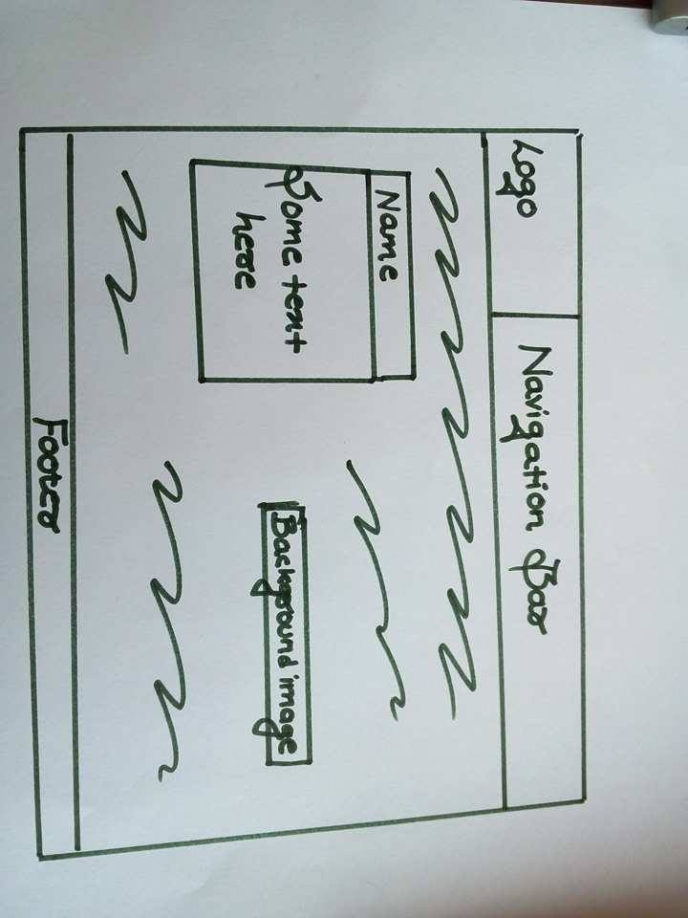I created the sketch of my home page first. I thought of adding a background image in my home page to give it an elegant look. For the first timers visiting my websites I wanted them to know what my website contains. Therefore, I made the home design as simple as possible. The logo remains on the top left hand side corner of the webpage and the navigation bar beside it. There will be a footer at the end of the website containing links to contact me directly through different social media.

### Bio page sketch:

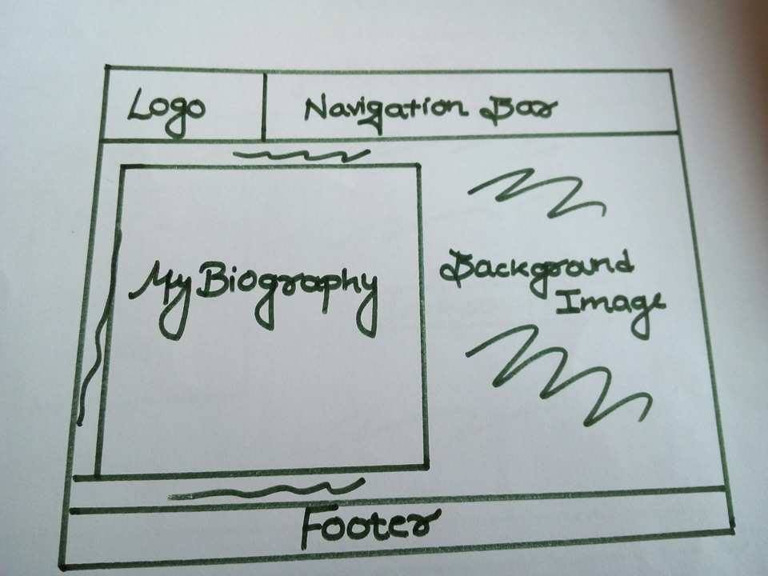Following the homepage a similar design was used to create my biography page which includes a background image and a simple section where the visitors can read about my bio. The navigation bar, logo and the footer designs remain consistent throughout all the pages.

### Contact page sketch:

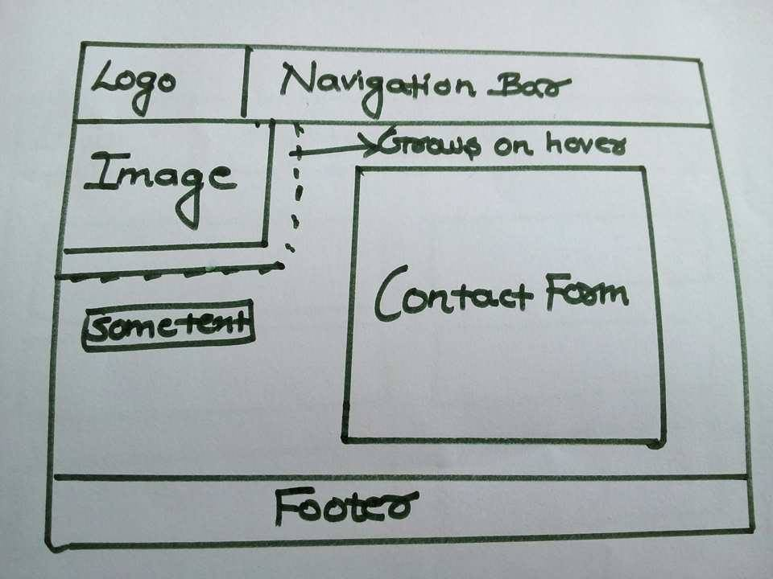Making a website user friendly must be a developer’s first priority. Therefore, I created my contact page keeping that in my mind. Keeping a simple form in the middle, I have my contact photo in the left hand side of the page right below the logo. The image scales and grows larger on hover.

### CV page sketch:

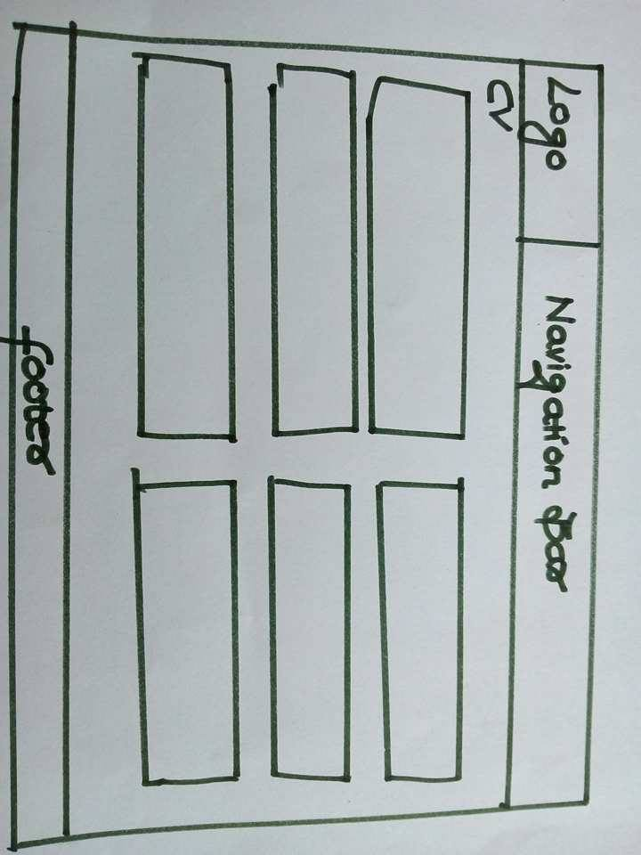I first decided to keep a simple CV design but then decided to add boxes to further enhance my website looks. Every box contains different information about me.

# Wire frames:

After completing my rough sketches, I had a very clear idea about the designs to be created for my webpage. Then, without any delay I started working for the wireframe of my webpage.

## Wireframe of my home page:

Keeping the designs of the home page in my mind, I created a wireframe of it to make my designing part easy. The wireframe includes navigation bar, logo part, main content with some text and a background image.

Below is the wireframe of my home page:-

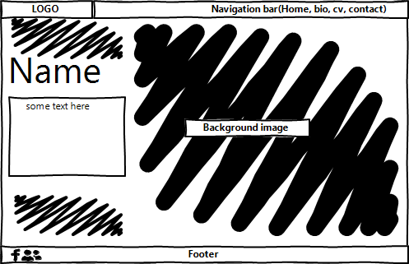

## Wireframe of my biography page:

After creating wireframe for my home page, I started making wireframe for my biography page which includes navigation bar, logo part, a section for my biography, a background image and the footer section.

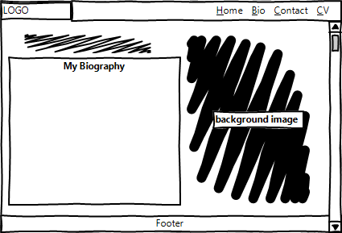Below is the wireframe of my biography page:-

## Wireframe of my CV page:

After making wireframe of my biography page, I started creating wireframe of my CV page which includes the consistent header (navigation bar and logo) and footer section. The main content includes six different sections for different topic heads and the information that needs to be included in the certain topic.

Below is the wireframe of my CV page:

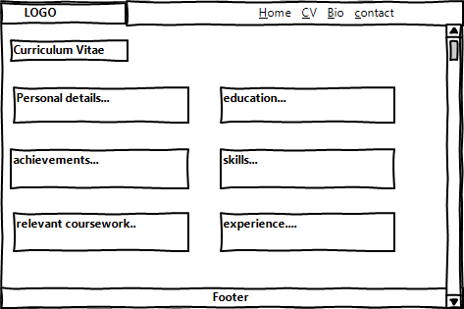

## Wireframe of my contact page:

Finally after the CV page, I created wireframe for my contact page which includes the same header and footer along with a image in the top left side of the main content and a contact form in the center part.

Below is the wireframe of my CV page:

# Designing my logo:

After the design of my rough sketch and wireframes I finally decided to work on my logo. The logo will define what I am and what my website looks like. As I have followed the path of simplicity throughout the website, I thought of giving my logo a simple and an elegant look.

Below is the image of my logo:-

# Using good practices:

## Page load speed:

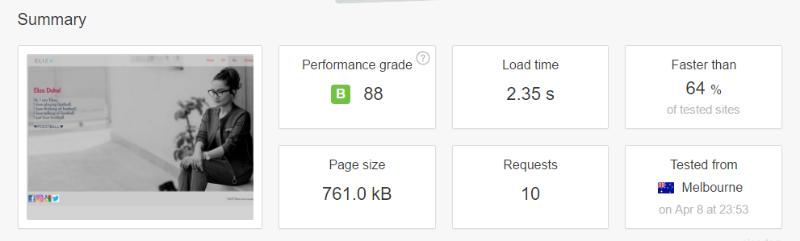Speed plays a vital role in the world of internet. Speed is an affecting factor for each and every website. Nobody wants to visit a website which loads very slow and is very much time consuming. So, it’s always a good practice to check whether your website is fast or slow. If its speed is good that’s great and if not, you can make some changes in the website to make it more efficient. So, as a good practice I have also tested my website on tools.pingdom.com to check the speed of my website. The result of the test is shown below:-

So, as seen in the above picture the loading time of my website is 2.35s which is 64% faster than all of the tested websites on tools.pingdom.com.

## Visual appeal:

During the process of creating my personal website, I went through some of the other websites to get some ideas for the designs. But, I wanted to add some uniqueness of my own in the website. I even believe that, through simplicity comes great beauty. So, I tried to make my website simple but effective as well. My website looks simple but I do believe that people will get attracted towards my website. To create a good website, you surely need to be a good coder but you should be a good designer along with it. I tried to maintain good color combinations and a suitable background images for my website. So, I believe my website looks good and effective to all the people who will visualize it.

## Navigation:

One of the important aspects of good practices while creating a website is considered as the navigation system. Every web developer should be aware of the kind of website he/she is developing. User friendly websites are very important for making the website effective. And to make the website user friendly, navigation system should always be kept in mind. Every user should find it easy to switch pages through the navigation panel at any time without any confusion. So, as my theme is based on simplicity, the navigation panels are easy to use as they give clear idea about what the page is and you can anytime return back to the home page through my logo. If you hover and click on my logo wherever or whichever page you are in you will be automatically directed to my home page. Hence, navigation system plays an important role for making a website perfect and user friendly.

# Validation test for html codes:

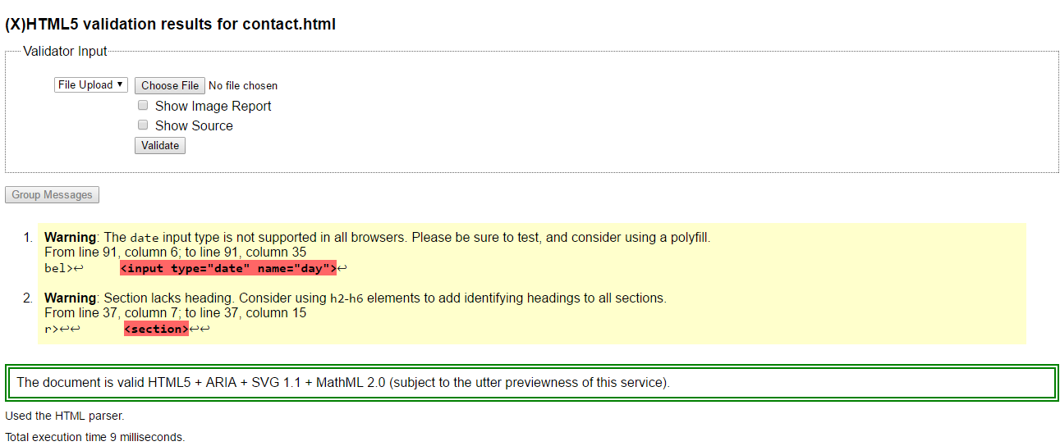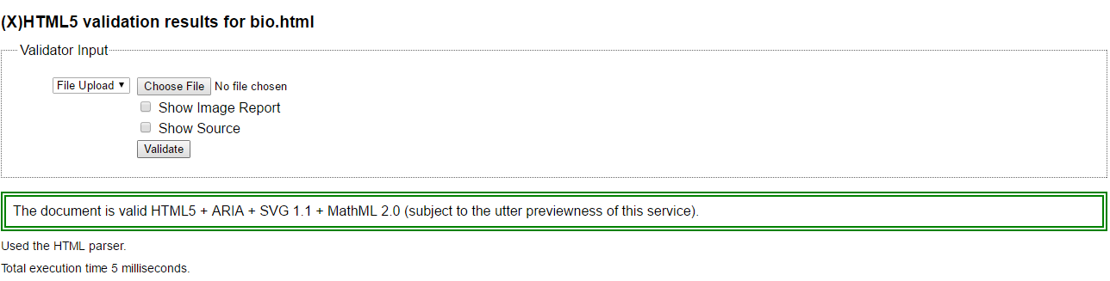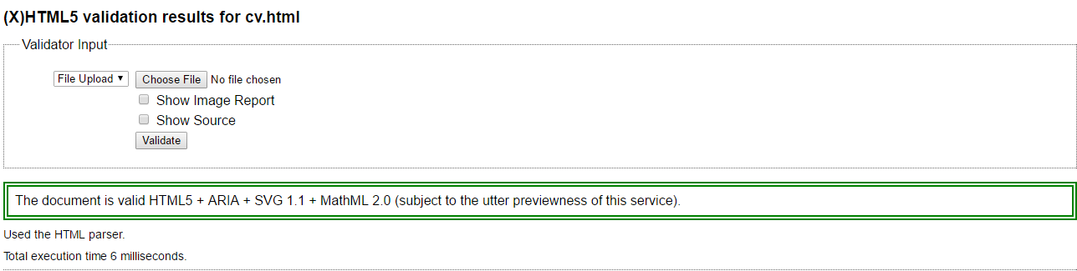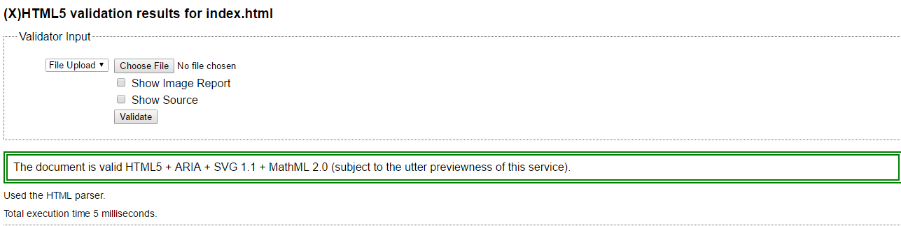

# Validation test for CSS codes:

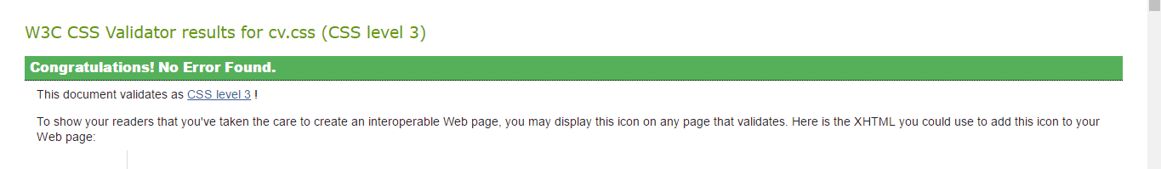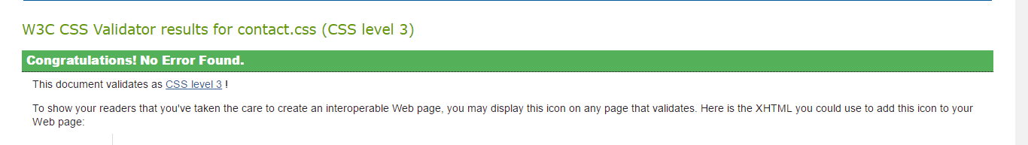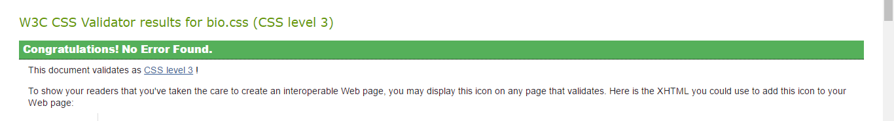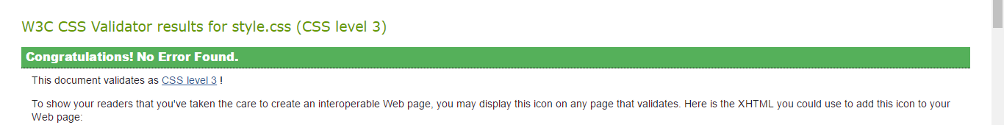

# Progression of my webpage over 6weeks

It is clearly not a one day or a one week job to complete a personal webpage. It took me 8 weeks altogether to finish my website with all the contents in it.

As mentioned above i started doing my work form the research part. Then I continued it by creating rough sketches immediately followed by the wire frames. And all this process took me one week.

In the second week, I started my designing part. I started writing codes in atom. First I thought of creating the navigation bar for my home page as I was working on the homepage at the very beginning and I did the same as well. I created a navigation bar for my website at first. Then, I tried to match colors. Color combination is really tough because you really have to think and do research for a long time to get a perfect color combination.

## First look of my website (2nd week):

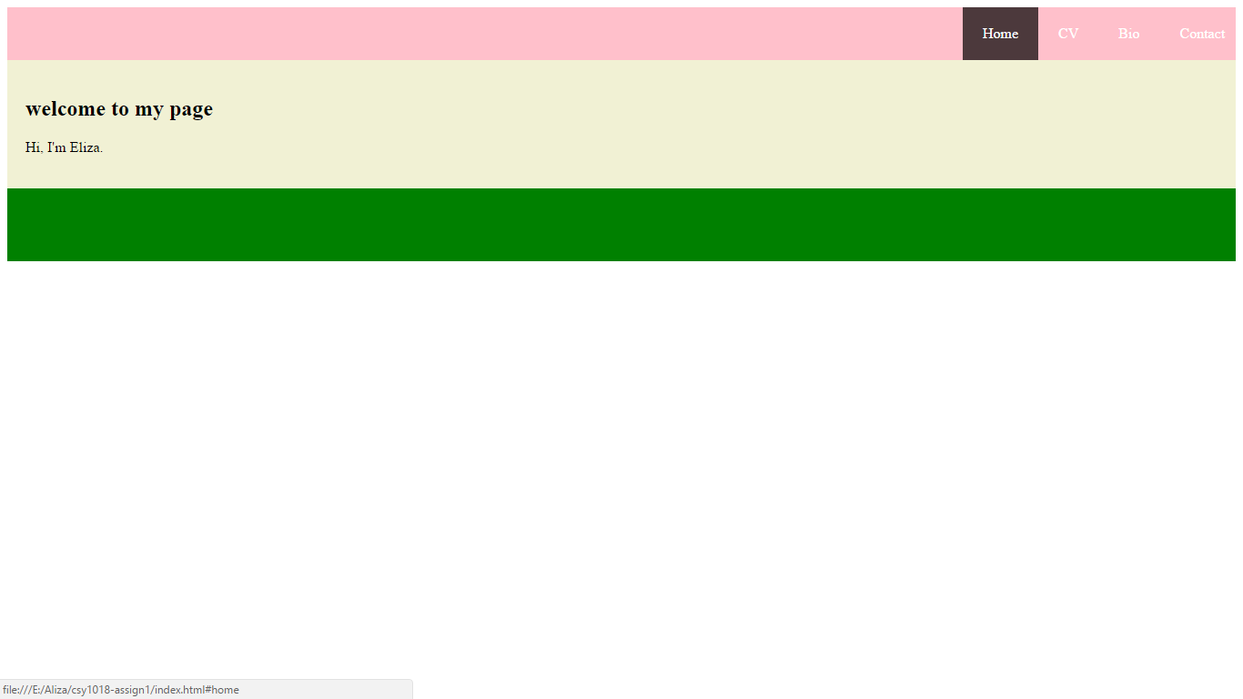

So, after creating a navigation panel, this is what my website looked like. On hover, it gives some transition. This was the first look of my website. Those colors were just the sample for that period of time.

## Second look of my website: (2nd week):

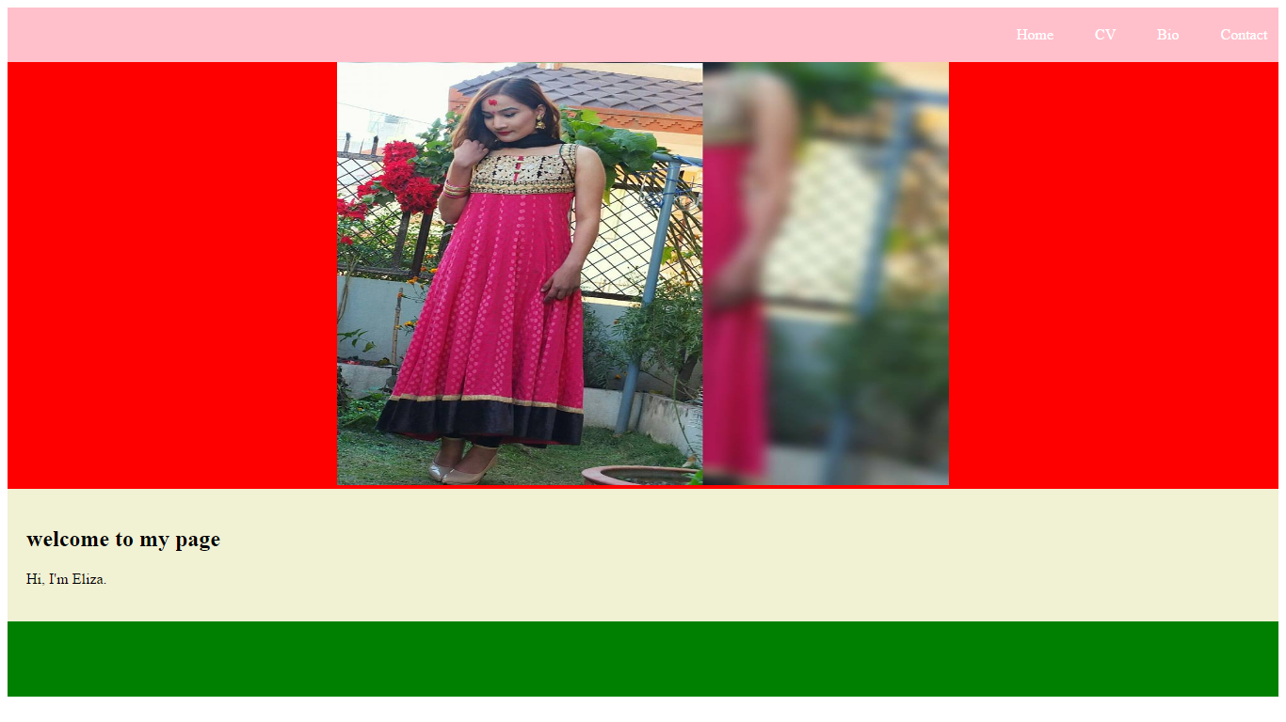After the navigation part, I tried to add a picture and create something different but it was not impressive at all. So, I dropped the idea of adding a separate picture and thought of sticking to my own plan of adding a background picture. The separate picture website looked something like this:

So, this is how it looked like after adding a picture to it.

## 3rd week progression:

After the second week, I totally focused on my own design and started creating it by trying a number of background images. It was tough job to select a perfect background image. I went through a number of photos, edited them to make it suitable for my website but it was really very time consuming. I wasn’t sure for so many weeks about the background image.

### Trying different background images:

These are some of the images I tried but not finalized any of them:

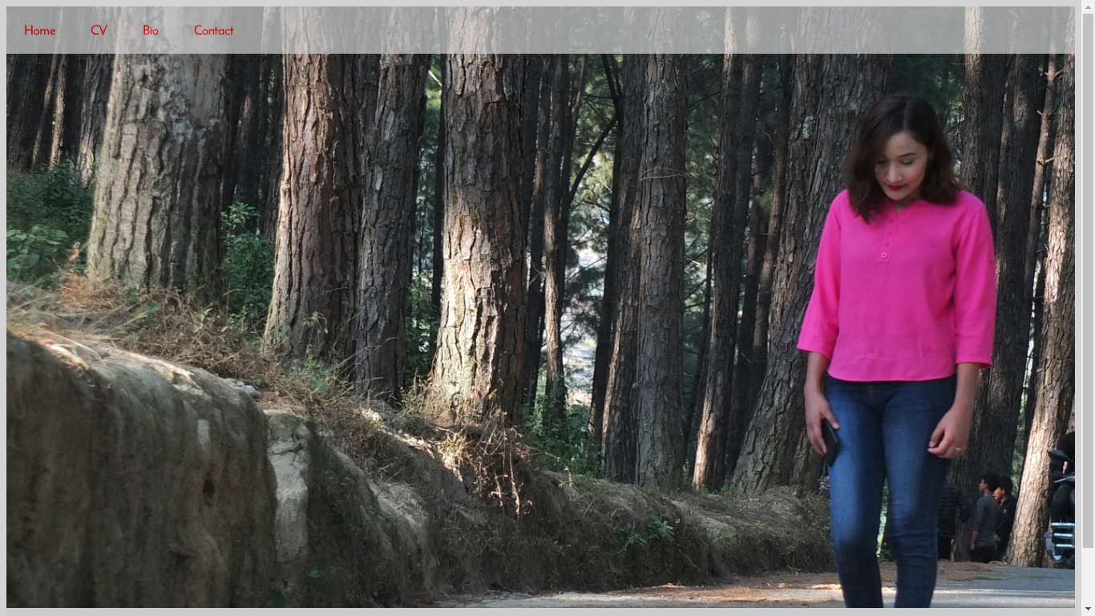

This one looked okay but I was not satisfied with this one.

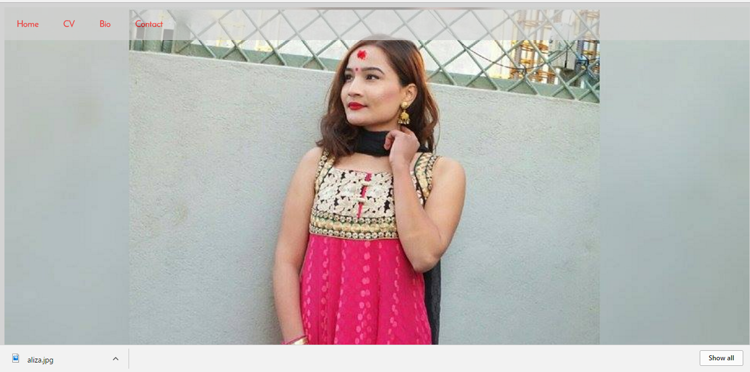

The picture is pretty but it just doesn’t go with my website and the design that I had already thought in my mind.

So, after number of trials I finalized one after a very long time.

## 4th to 5th week progression:

Most of the activities happened in this period of time. I was going slowly in everything but I geared up and started doing everything I could to make my website look better day after day. I don’t really have any pictures or evidences to present it here but I completed my website within this period of time except some of the material designing part. I included all the contents in my page. I filled my biography, CV and the main section of the homepage. I really got some problems in finalizing the colors and the fonts but after trying out several items I finalized them all.

## In the last week:

Finally in the last week, I added some transitions, transformations, some cool Google API fonts. I tried out new designs. Moreover, I fixed everything up and finally completed my website.

# Final look of my website

Below are the images of my final websites:

## Final look of my home page:

## 

This is how my home page looks like at this moment.

## Final look of my CV page:

This is how my CV page looks like at this moment.

## Final look of my biography page:

This is how my biography page looks like at this moment.

## Final look of my contact page:

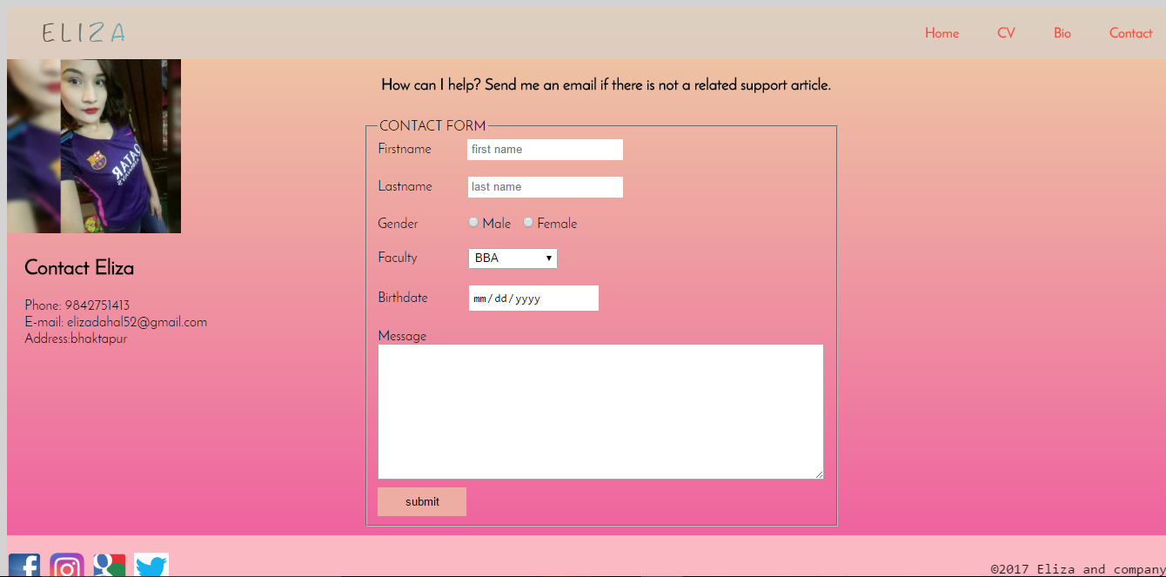

This is how my contact page looks like at this moment.

# Conclusion:

Finally, after a long run of six wonderful and challenging weeks, I completed my webpages in the proper time by following all the good practices. It was fun to do research, create roughs, wireframes and then do the designing part. I followed every step from the first and ended up creating an average website for myself. As mentioned above I followed and went through all those steps to create the final website. Following steps makes your work easier. So, this is how I created my personal webpage which contains all my personal and professional information.

# References:

**Refsnes Data. 1998. *W3Schools online web tutorials*. [ONLINE] Available at:**[**https://www.w3schools.com/**](https://www.w3schools.com/)**. [Accessed: 1April 2017].**

**MIT, ERCIM, KEIO, BEIHANG. 1994. *Markup validation service*. [ONLINE] Available at:**[**https://validator.w3.org**](https://validator.w3.org/)**. [Accessed: 8April 2017].**

**MIT,ERCIM,KEIO. 1994. *CSS validation service*. [ONLINE]Available at:**[**https://jigsaw.w3.org/css-validator/**](https://jigsaw.w3.org/css-validator/)**. [Accessed: 8April 2017].**

**Pingdom. 2017. *Website speed test*[ONLINE] Available at:** [**https://tools.pingdom.com/**](https://tools.pingdom.com/) **[Accessed: 8April 2017]**

**Anon, Google Fonts  |  Google Developers. *Google Developers*. Available at: https://developers.google.com/fonts/ [Accessed April 5, 2017].**